MQ-3 Alcohol Sensor Module + Circuit Explanation
The basic principle of the MQ-3 alcohol sensor can be briefly described as a device that converts the detected alcohol concentration into a useful electrical signal. Based on the strength of these electrical signals, information related to the presence of the target gas in the environment can be obtained. The MQ-3 gas sensor consists of a ceramic tube, a silicon dioxide sensitive layer, measuring electrodes, and a heater. The sensitive element is fixed inside a plastic or stainless-steel cavity, and the heater provides the necessary operating conditions for the gas-sensitive element. The packaged gas-sensitive element has six output pins, four of which are used for signal extraction and two for supplying heating current.
During operation, the heating voltage of the gas sensor can be either AC or DC 5V. After heating, the concentration of combustible gas in the heated environment increases rapidly, and the internal resistance of the sensor decreases quickly. After processing, the detection signal is converted from a resistance change into a voltage value, which can then be used for subsequent A/D conversion and processing.
The rate of change of sensor resistance is closely related to alcohol concentration and ambient temperature. To minimize the maximum error in alcohol concentration measurement, a suitable temperature must be found. In general, the sensor should be preheated for 5 minutes before measurement. After preheating, adsorption on the surface of the semiconductor particles changes the carrier concentration of the material, thereby changing its conductivity and reflecting the concentration change.
The semiconductor-type MQ-3 alcohol sensor has the advantages of high sensitivity, simple circuit design, convenient use, low cost, good stability, and long service life. It can convert the gas signal into a voltage signal output, so it is widely used. The MQ-3 alcohol sensor can be used for detecting alcohol concentration in the breath of motor vehicle drivers, as well as for site monitoring in environments where operation after drinking is prohibited. It can also be used for ethanol vapor detection in other places.
Note: after the sensor is powered on, it needs to be preheated for about 20 s before the measured data becomes stable. Heating of the sensor is normal because there is a heating wire inside.
- Module Parameters
- Analog output: 0-5V voltage; the higher the concentration, the higher the voltage.
- Power consumption (current): 150 mA.
- High sensitivity and good selectivity to ethanol vapor.
- Long service life and reliable stability.
- Fast response and recovery characteristics.
The circuit interface diagram of the MQ-3 alcohol sensor is shown below.
Circuit interface diagram of the MQ-3 alcohol sensor
The physical picture of the MQ-3 alcohol sensor is shown below.
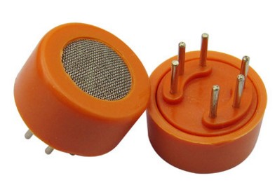
Physical picture of the MQ-3 alcohol sensor

